SJESR: Vol. 0, No. 0, yyyy, pp-pp College of Engineering / University of Samarra
 |   SAMARRA JOURNAL OF ENGINEERING  SCIENCE AND RESEARCH
Manuscript title: Please use 16 pt. Cambria font

First Author^{1*}, Second Author ² and Third Author ³
1- First affiliation, City, Country
2- Second affiliation, City, Country
3- Third affiliation, City, Country
Article Information |  |  | Abstract
Received: dd/mm/yyyy  Accepted: dd/mm/yyyy |  |  | This document gives you guidelines on preparing manuscripts for submission to SJESR, also provides the rough format of finished articles. The first word of the manuscript title should be capitalised, with all other words lowercase. A full list of author names should be placed under the title. Author names should be separated by a comma apart from the final name, which should, instead, be preceded by ‘and’ (see the example above). The number of keywords could be 3 to 5 keywords. The Abstract should must be: Cambria; font size 10; one paragraph; with 150 to 200 words. It must not cite any references, and any acronyms used in the Abstract must be expanded.
Keywords:
Keyword1, Keyword2, Keyword3, Keyword4,
and Keyword5.
*Corresponding Author
E-mail:

I. Main text
The main text should be set in a one-column format. Please use 12 pt. Cambria font (bold) for the titles of sections, 12 pt. Cambria font (bold and italic) for the titles of subsections, and 12 pt. Cambria font for the main text, with a line spacing of 1.15, and please number all pages. Each article should have clearly headed sections (The common sections could be: Introduction, Materials and methods, Results and discussion, Conclusion, and References). New sections should be separated by a blank line.
All of the References present in the References Section must be cited in the main text, in numerical order and in square brackets – i.e. [1]. Multiple references can be bracketed together, for example [1, 2] or [3–5].

  - Figures and tables
Figures and tables must be embedded within the main text and must also be cited in numerical order. Tables should be labelled Table 1, Table 2, etc. and Figures should be labelled, for instance, Fig. 1 and Fig. 2, with any sub-Figures labelled as follows: Fig. 3(a), Fig. 4(c) and so on. Figures that contain sub-Figures can be cited as a whole (e.g. Fig. 1 shows…), or separately (e.g. Fig. 1(a) shows…) – if citing sub-Figures separately, please ensure that all parts are cited. Use 10 pt. Cambria font for the titles of the figures and tables. Figures and tables must also be separated from the main text with a blank line.
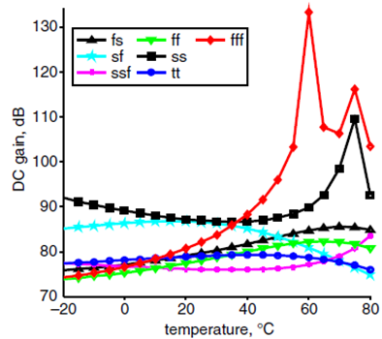
(a) (b)
Fig. 1. To ensure traces are distinguishable in black and white, please use a variety of shapes and/or dashed lines (a) Sub-captions should be placed below the main caption (b) Label axes in the format: angle, deg (what axis shows, comma, units).

Please ensure that Figures are clearly labelled, as discussed above, placed near to where they are cited and that they are of good quality; i.e. clear to understand and not blurry. Please ensure that Figures are understandable when viewed in black and white.
Note: if possible, please try to avoid setting line-drawings and photographs in the same Figure since photographs require different processing in order to maintain quality.

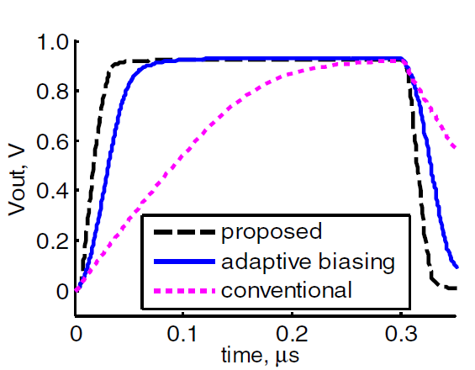
(a) (b)

Fig. 2. All text in Figures should be lowercase, unless the word would normally be capitalised (i.e. ‘LED’, or ‘Butler matrix’) (a) Sub-Figures can be placed adjacent to each other or on new lines (b) Figures such as the above do not need to be placed in a border.

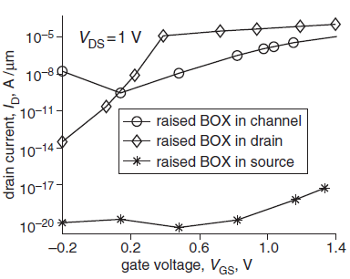

Fig. 3. Zero should always be written ‘0’ – do not include decimal places after zero (i.e. not ‘0.0’); set all legends in boxes within the Figure.

Please see Table 1 as an example of their presentation. Please ensure all Tables are cited in numerical order, as with the Figures and References. Unlike Figure captions, Table captions are placed above the corresponding Table. The table contents are written in 10 pt. Cambria font.

Table 1. The font size within the Table should match that of the main text, to ensure that it is clearly readable when printed.

Name | Proportion (%) | Frequency (GHz) | Area (mm²)
One | 45 | 64 | 12.3
Two | 55 | 18 | 3.4
Three | 17 | 24 | 5.2

  - Equations
Use 12 pt. Cambria font (italic) for the writing the equations. All numbered equations such as (1), below, should be referred to in the main text using the bracketed number only.. Numbered equations or substantial maths should be set on a separate line from the text, as follows:

D_{H} = [2π I(90,φ)] / [ ∫₀ ^{2π} I(90,φ)dφ] (1)

Equation editors can be used, as long as they are in English. All variables must be defined in the main text.

$X_{e1}\left(s.n_{1}.k_{1}\right)=\left(\begin{matrix}k_{1} \\ s\end{matrix}\right)\frac{n_{1}!}{\left(n_{1}-s\right)!}\sum_{v=0}^{min⁡(n_{1}-sk_{1}-s)}{(-1)}\left(\begin{matrix}k_{1}-s \\ v\end{matrix}\right)$ (2)

2. Construction of references
The journal adopts the IEEE reference style. The IEEE style is a numeric style, where citations are numbered [1] in the order of appearance.
Only publications cited in the text should be included in the reference list. Up to two authors can be mentioned in text references; more than two authors should be shortened to the author’s name with et al. However, in general you do not need to mention the authors by name, just use the numeric citation in square brackets.
Here are some examples of IEEE style citation:
“... as shown by Brown [4], as previously stated.”
"The theory was first put forward in 1987 [1]."
“For example, see [7].”
"Several recent studies [3, 4, 15, 16] have suggested that..."
The example above may also be formatted as:
“Several recent studies [3], [4], [15], [16] have suggested that…”
At the end of your work, list full details of all of the sources which you have cited in your text in a section headed References, in numeric order. References listed must follow IEEE formatting guidelines. Use 10 pt. Cambria font in writing the list of references.
In your full reference list, give the authors’ names. You can abbreviate authors’ names using ‘et al.’ if there are six or more authors.

2.1 Reference examples

For journal article:
[Ref number] Author’s initials. Author’s Surname, “Title of article,” Title of journal abbreviated in Italics, vol. number, issue number, page numbers, Abbreviated Month Year.

[1] F. Yan, Y. Gu, Y. Wang, C. M. Wang, X. Y. Hu, H. X. Peng, et al., "Study on the interaction mechanism between laser and rock during perforation," Optics and Laser Technology, vol. 54, pp. 303-308, Dec 2013.

Note: the above example article is from a journal which does not use issue numbers, so they are not included in the reference.

For book:
[Ref number] Author’s initials. Author’s Surname, Book Title, edition (if not first). Place of publication: Publisher, Year.

[2] I.A. Glover and P.M. Grant, Digital Communications, 3rd ed. Harlow: Prentice Hall, 2009.

For book chapter:
[Ref number] Author’s initials. Author’s Surname, “Title of chapter in book,” in Book Title, edition (if not first), Editor’s initials. Editor’s Surname, Ed. Place of publication: Publisher, Year, page numbers.

[3] C. W. Li and G. J. Wang, "MEMS manufacturing techniques for tissue scaffolding devices," in Mems for Biomedical Applications, S. Bhansali and A. Vasudev, Eds. Cambridge: Woodhead, 2012, pp. 192-217.

Acknowledgment
This Section is optional but can be used to recognise the support from certain funds or organisations,

References
[1] F. Yan, Y. Gu, Y. Wang, C. M. Wang, X. Y. Hu, H. X. Peng, et al., "Study on the interaction mechanism between laser and rock during perforation," Optics and Laser Technology, vol. 54, pp. 303-308, Dec 2013.
[2] I.A. Glover and P.M. Grant, Digital Communications, 3rd ed. Harlow: Prentice Hall, 2009.
[3] C. W. Li and G. J. Wang, "MEMS manufacturing techniques for tissue scaffolding devices," in Mems for Biomedical Applications, S. Bhansali and A. Vasudev, Eds. Cambridge: Woodhead, 2012, pp. 192-217.

